  - Instructional hour template and calendar user guide

Instructional Hours Calendar Manual

Idaho Department of Education
Public School finance

650 W State Street, 2nd Floor
Boise, IDaho 83702
208 332 6800 office / 711 TRS
www.sde.idaho.gov

Created 03/08/2023
TABLE OF CONTENTS
Calendar Overview 3
How to Submit 3
Staff Development Days 4
Modified Days of Instruction 4
Template Overview 4
Filling Out the Calendar Forms 4
Step 1: Opening & Saving Your Template 4
Step 2: Entering Header Information 5
Step 3: Color-Coding the Calendar 5
Step 4: Calculating Instructional Time Tables 7
Regular Day of Instruction Table 7
Modified Day of Instruction and Staff Development Hours Table 7
Step 5: Calculating Total Hours & Meeting the Minimum Requirement 9
Step 6: Contact Information & Review 10
REMINDER: How to Submit 10
Frequently Asked Questions 11

Calendar Overview
Idaho Code 33-512(1) requires schools to annually adopt and implement a school calendar which provides the following minimum number of instructional hours:
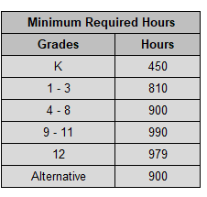
Instructional hours include the time when students are under the guidance and direction of a teacher engaged in the teaching process. School assemblies, testing, and other instructionally related activities directly involving students may be included as instructional hours. Transportation to and from school, lunch periods, breaks, recess, passing time, etc. should not be counted as instructional time.

Calculating the total hours of instruction offered for each grade grouping is a multi-step process. A school district/charter school with multiple buildings will need to work with each building individually to determine the exact hours and minutes of instruction.

How to Submit
Calendars for the upcoming school year are due to School Finance no later than May 31. Submit the forms by emailing Amber Worthington at aworthington@sde.idaho.gov

The Calendar forms are available on the Idaho Department of Education website https://www.sde.idaho.gov/finance/ under the header of Calendars, School Calendar Forms.

Please send in excel format and as a single file.

If you have any questions during this process, contact:
- Amber Worthington 208-332-6829 aworthington@sde.idaho.gov

Staff Development Days
Staff development is time set aside for the training of teachers to allow for the development of teaching skills. Staff development does not include teacher prep time, workdays, parent-teacher conferences, mentor time, etc. Idaho Code 33-512(1)(c) allows up to 22 hours of Grades 1-12 and up to 11 hours for Kindergarten to count as instructional hours. A school may choose to offer fewer than or more than 22 hours of staff development, but may only include up to 22 hours (11 hours for Kindergarten) as instructional hours.

Idaho Code 33-512(1)(d) states that student and staff activities related to the opening and closing of the school year, grade reporting, program planning, staff meetings, and other classroom and building management activities do not qualify as staff development or instructional time.

Staff development may take place before the first day of school, during the school year, or after the last day of school. Staff development days can be set by the local school board as deemed appropriate.

Modified Days of Instruction
A modified day is any day when the instructional hours deviate from regular day of instruction. Record modified hours in the tables on the calendar form. If a modified day is combined with staff development, record the modified hours and staff development hours in the appropriate tables on the calendar form.

Template Overview
There are 5 tabs in the Instructional Hours Template for you to use.
- Kindergarten Half Day Template
- Kindergarten Full Day Template
- Grade Levels Template (use for grades 1-12 and alternative calendars)
- Example
- Adding a New Tab

Filling Out the Calendar Forms
Key note for the calendar form(s): Complete all tan colored cells and tabs in the form.

Step 1: Opening & Saving Your Template
- Open the template posted to the Idaho Department of Education website here: https://www.sde.idaho.gov/finance/
  - Go to Resource Files > Calendars > School Calendar Forms
- Rename your template to include your 3-digit district/charter number
  - Example: 100_Instructional Hours Calendar 2023-2024

Step 2: Entering Header Information
Begin filling out the header section on the form
- Click in the Select District/Charter Name cell
  - Select your district/charter from the drop-down menu
  - This will automatically populate the IFARMS Number cell for you below
- Fill out the Building Numbers cell
- List Grades Served for the respective calendar
  - Combine all buildings and grades with the same schedule into one calendar form. If the exact same hours and minutes of instruction are offered to more than one grade grouping or building, only one calendar should be completed for that grouping
- Indicate if this calendar represents a 4-Day School
  - Enter ‘Y’ if the calendar is a 4-day school. Enter ‘N’ if the calendar is not a 4-day school
    - Contact School Finance if you are unsure if you qualify as a 4-day calendar
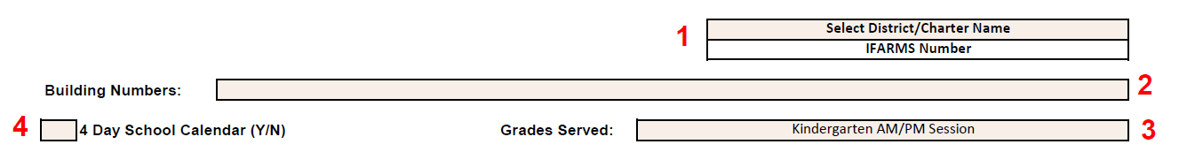

Schools which regularly schedule shortened days on a particular day of the week, are not considered 4 Day Schools. Be sure you noted the checkbox in the header information on the form accordingly.

Step 3: Color-Coding the Calendar
- Begin by entering the First Day & Last Day of Instruction into the appropriate text box
Next you will use the Cell Formatting Reference Key to guide you through the process of color coding your monthly calendars.
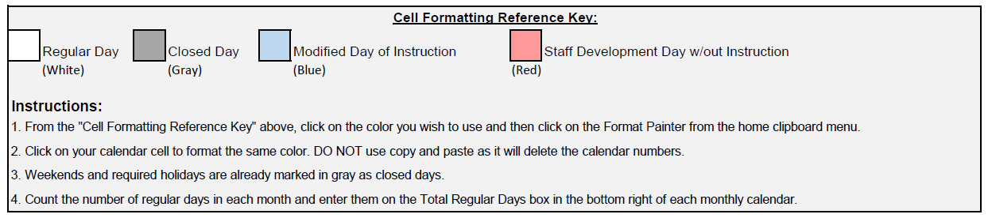
- Color code ALL days of each month:
  - Regular Day
  - Closed Day
  - Modified Day of Instruction
  - Staff Development Day w/out Instruction
Regular Instruction days are default on the calendar along with Closed Days for required holidays and weekends.
Example of completed calendar:

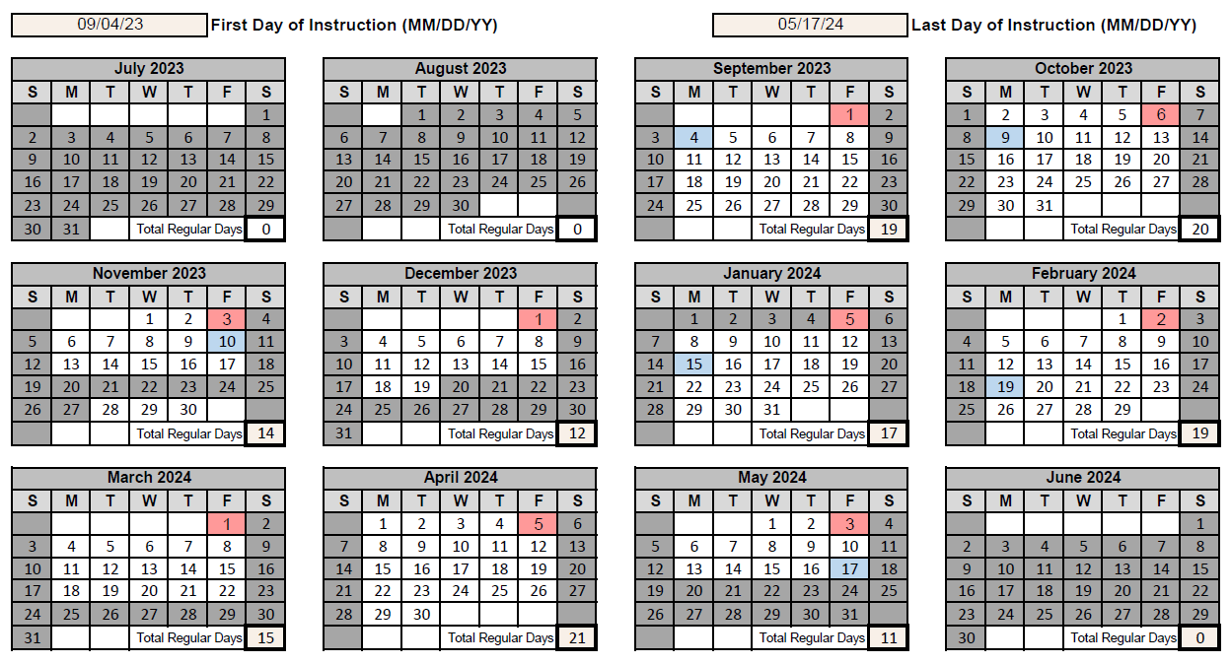

- Count the Regular days (white cells) in each month and total them in the corresponding Total Regular Days box in the bottom right corner of each month
  - These totals will auto-populate the Regular Hours of Instruction Table at the end of the form

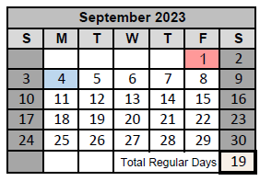

Step 4: Calculating Instructional Time Tables
Below the monthly calendars, there are time tables for each color-coded day type to provide time totals.
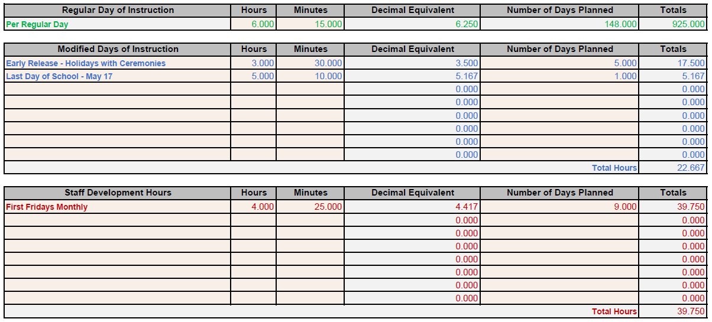

Regular Day of Instruction Table
- Fill in the Hours and Minutes columns. The table will auto-populate the decimal equivalent (calculated from your input), and number of days planned (tallied from the monthly calendars Total Regular Days boxes).

Modified Day of Instruction and Staff Development Hours Table
- Fill in the Hours and Minutes columns. The table will auto-populate the decimal equivalent (calculated from your input).
  - Example: If every Wednesday is a delayed start or an early release, do not list the date for each Wednesday. Instead, enter “Wednesdays” and enter the appropriate Number of Days Planned.
  - If you have split days with both instructional hours and staff development, enter the number of instructional hours in the Modified Days of Instruction table, and the number of staff development hours in the Staff Development Hours table. This way, you accurately account for all your planned time.
- Fill in the Number of Days Planned column. The table will auto-populate line by line totals of hours (calculated from your input).
You may enter more than the allowable 11 or 22 hours for staff development into this table. The grand totals at the end of the form will cap the amount counted.

Step 5: Calculating Total Hours & Meeting the Minimum Requirement
Below the time tables is a summary total of the tables and a verification of the minimum hour requirement. This section auto-generates based on the information provided in the tables listed in Step 4.
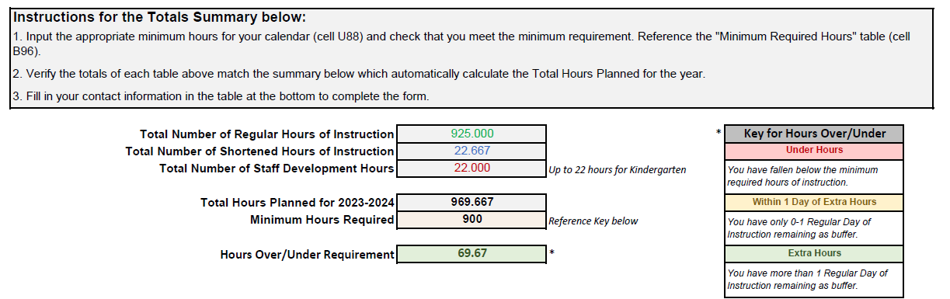

- Based on your grades served, enter the Minimum Hours Required in the appropriate text box
  - Reference the Minimum Required Hours table below this section if needed.
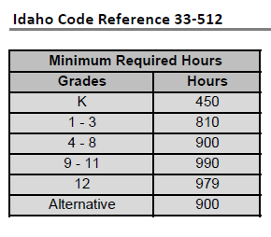

While it is not mandatory, it is strongly encouraged you plan additional hours to exceed the minimum requirement in the event of a calendar revision.

Calendars are based on grade groupings, the highest-grade level identified on the calendar form will set the minimum instruction hours required for that grouping.
Grade 12 calendars must be submitted separately to receive the reduction in hours for grade 12.
Example: For a calendar serving grades 1–7, your minimum hours required will follow the 7th grade requirement which is 900 hours.

Step 6: Contact Information & Review
Lastly, be sure to fill out the contact information for this form.
Provide the contact information for follow-up questions regarding the instructional hours and contact for Emergency Closure adjustments/board minutes.
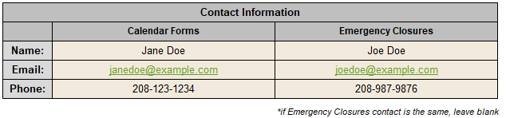
Please list both contacts, however, if those contacts are one and the same, you may leave the Emergency Closure contact side blank.

Please review the entirety of your form(s) before submitting.

REMINDER: How to Submit
You made it through your instructional hours calendar form!

Calendars for the upcoming school year are due to School Finance no later than May 31. Submit the forms by emailing Amber Worthington at aworthington@sde.idaho.gov

The Calendar forms are available on the Idaho Department of Education website https://www.sde.idaho.gov/finance/ under the header of Calendars, School Calendar Forms.
Please send in excel format as a single file.
If you have any questions during this process, contact:
- Amber Worthington 208-332-6829 aworthington@sde.idaho.gov

Frequently Asked Questions
Who do I contact if I have any questions?
Please contact Amber Worthington (aworthington@sde.idaho.gov).

Why is it better to have a day of no attendance (vacation day) rather than a day of poor attendance?
Average Daily Attendance (ADA) from the first day of school through the first Friday in November is one of the factors used in determining salary-based apportionment and benefit apportionment.

It is in the best financial interest of a school district to maximize its attendance during this time to maximize its salary-based and benefit apportionments. A low day of attendance will lower the average daily attendance for the week. A vacation day will simply make the week a four-day week rather than a five-day week.

The Idaho Department of Education encourages schools to examine their attendance history from prior years and isolate days that routinely have low attendance. For example, is attendance significantly impacted the Friday before Labor Day weekend? During the local fair? During the opening of hunting season or harvest? Once low attendance days have been identified, a school may want to consider adjusting its calendar to minimize the impact low attendance has on state revenues.

I thought we had to have a minimum of 180 student contact days?
No. Idaho Code 33-512(1) requires a school to provide its students a specific number of instructional hours, not a specific number of days of instruction. Neither Idaho Code nor the Idaho Department of Education require a school to provide a minimum number of instructional days.

We initially set our calendar in May of the prior school year and sent it to the Idaho Department of Education. Since then, we’ve made several changes. Do I need to send the Idaho Department of Education a new calendar?
It is important the Idaho Department of Education be notified of all changes to the original calendar. If the changes are extensive, a new calendar will need to be submitted to the Idaho Department of Education. Otherwise, an email detailing the changes is sufficient. Using the new information, the original calendars will be updated to reflect the changes.

Why do I have to complete a separate calendar for all of my Kindergarten sessions with different schedules but having the exact same number of hours?
Each unique Kindergarten schedule must independently satisfy the 450 minimum instructional hour requirement. Unforeseen emergency closures due to adverse weather conditions or facility failures could impact one Kindergarten session but not the other.

If all Kindergarten sessions have the exact same schedule, complete one calendar and make copies of the template. Indicate on each copy the schedule for that building as AM, PM, full-day, etc.

Can we offer a four-day school week?
Yes. One of the duties of your school board is to determine your school calendar. On the Public School Finance page of the Idaho Department of Education website, there is a posted List of Idaho School Districts and Charter Schools on a Four-Day Week.

If our Kindergarten schedule is less than five days a week, do I need to mark the non-attendance days as vacation days?
Yes. Any day that students are not scheduled to be in session should be indicated as a vacation day by graying it out. For example, if Kindergarten is in session Monday, Wednesday, and every other Friday, mark all Tuesdays, Thursdays, and the “off” Fridays as vacation days.

Do seniors have to meet the 990 instructional hour requirement?
No. Idaho Code 33-512(1)(f) allows the instructional time requirement for Grade 12 students to be reduced by an amount of time not to exceed 11 hours of instructional time. These students must be identified on a separate grade 12 calendar.

Do I have to complete a separate calendar for Grade 12 students if their last day is a week earlier than Grades 9-11?
Yes. Anytime the instructional hours differ among a grade grouping (such as Grades 9-12), a separate calendar must be completed. A Grade 12 calendar is available on the Idaho Department of Education website. If Grade 12 students will have the exact same schedule as Grades 9-11, a separate calendar is not necessary.

Why do I need to send the Idaho Department of Education a copy of the school calendar that we give patrons along with the Idaho Department of Education calendars?
Having a copy of the “patron” calendar is very helpful when reviewing a school’s calendar. Oftentimes, we can answer questions that may arise during our review process by reviewing the patron version of the school calendar.

Can we have school on a holiday?
That depends on the holiday. Idaho Code 33-512(9) requires the following days be school holidays:
- New Year’s Day
- Memorial Day
- Independence Day
- Thanksgiving Day
- Christmas Day
Other holidays, as listed in Idaho Code 73-108, must be observed with appropriate ceremonies if it falls on a school day. These holidays include:
- Martin Luther King Jr/Human Rights Day (The third Monday in January)
- Washington’s Birthday (The third Monday in February)
- Juneteenth (June 19)
- Labor Day (The first Monday in September)
- Columbus Day (The second Monday in October)
- Veteran’s Day (November 11)

How do I compute ADA for staff-development days?
Contact Dean Reich at dreich@sde.idaho.gov

What is a shortened day? If students were in attendance for at least 4.0 hours, why would this be a shortened day on the calendar, but not for attendance purposes?
For calendar purposes, a shortened day is any day where planned instruction is less than regular hours/minutes of instruction. Don’t confuse a shortened session with the half day reporting for attendance reporting purposes. For ISEE attendance questions, contact Dean Reich at dreich@sde.idaho.gov

What should I keep in mind when determining the length of a shortened day?
For calendar purposes, any amount of time the student is under instruction is included as instructional hours. However, for attendance reporting purposes, each Grade 1-12 student under instruction 4.0 hours or more is counted as 1.0 ADA and any student under instruction at least 2.5 hours but less than 4.0 hours would reported as .5 ADA. While a shortened session of 2.0 hours would be included as instructional hours, no attendance would be reported for that day. ISEE attendance calendars would show that day as a vacation day, staff development day, or non-instructional time and individual student attendance would be reflected to match only their time present.

Do I have to list every shortened session in the table at the bottom of the calendar?
Maybe. Group shortened days that have the exact same instructional hours on one line. If the days are not consistent, list them separately in the table.
Is staff development limited to the length of the school day? Prior to the first day of school or after the last day of school?
No. Idaho Code 33-512(1)(c) allows each school district/charter school to determine when staff development will occur and its duration.

What are State In-Service Days?
There are no state-mandated in-service days. Historically, many schools have set aside the first Thursday and Friday of October for staff development to allow their staff to attend regional and state in-service meetings. Idaho Code does not require that these two days be set aside for staff development. It is up to your school district/charter school whether the first Thursday and Friday are staff development days.

What is an emergency closure?
It is important to distinguish between qualified emergency closures that allow a reduction in instructional hours from emergency closures which impact the reporting of ADA, but do not allow for a reduction in the minimum instructional hours required.

- For instructional hour purposes, Idaho Code 33-512(1)(c)(ii) allows a reduction in the minimum required hours of instruction by a total of up to 11 hours of emergency closures due to adverse weather conditions or facility failures.

- For attendance reporting purposes, Idaho Code 33-1003A states that “When a school is closed, or if a school remains open but attendance is significantly reduced because of storm, flood, failure of the heating plant, loss or damage to the school building, quarantine or order of any city, county, or state health agency, or for reason believed by the board of trustees to be in the best interests of the health, safety, or welfare of the pupils, the board of trustees, having certified to the Idaho Department of Education the cause and duration of such closure or impacted attendance, shall be considered as being the same as for the days when the school actually was in session or when attendance was not impacted.”

Instructional time lost due to closures for reasons other than adverse weather conditions or facility failure, such as widespread sickness, will not qualify as emergency closure when determining if a school has satisfied the minimum hours of instruction as required per Idaho Code 33-512(1). However, for purposes of reporting attendance, such closures do qualify as emergency closures if they have been approved by a school’s trustees as an emergency closure.

Regardless of the reason for the emergency closure, the board of trustees must certify to the Idaho Department of Education the cause and duration of impacted attendance or closure. A copy of the board minutes approving the emergency closure must be included with the Emergency Closure Form (available on the Idaho Department of Education website) submitted to the Idaho Department of Education.

If instructional time is lost due to school closures not due to adverse weather or a facility failure, then a school district/charter school must examine the impact of such closures on their instructional hours. If the closure(s) causes instructional hours to fall below the minimum required hours for a particular grade grouping, sufficient hours must be added to the calendar to ensure the minimum instructional hours as required in Idaho Code 33-512 are provided.

The following is a list of the more common school closures reported to the Idaho Department of Education. We have identified which would qualify as an emergency closure for reducing the minimum number of instructional hours required and/or would qualify as emergency closures when submitting attendance through ISEE. This list is not meant to be a comprehensive listing.

Reason | Reduction in Instructional Hours Allowed | Emergency Closure for Attendance Reporting
Adverse Weather (snow, flood, etc.) | Yes | Yes
Facility Failure (no heat, fire, etc.) | Yes | Yes
Quarantine (wide-spread sickness) | No | Yes
Reason as determined by the trustees to be in the best interests of the health, safety, or welfare of the students | No | Yes
Funeral of a student or staff member | No | Yes
State athletic tournaments | No | No
Insufficient staffing | No | No
School building not ready due to construction delays | No | No

