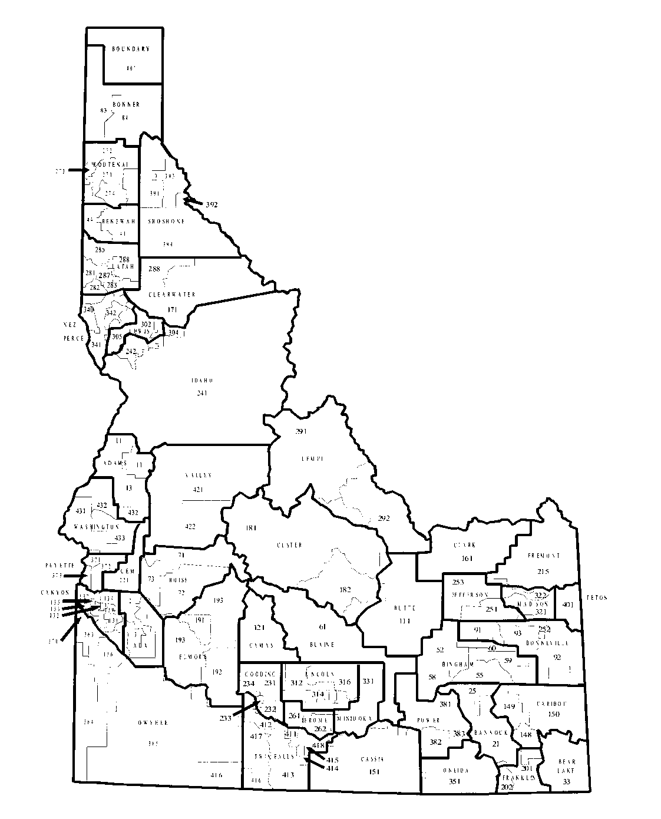

SCHOOL DISTRICT BUDGET
2024 – 2025

Name of School District/Charter School

Organization Number

County

Debbie Critchfield
DEPARTMENT OF EDUCATION
P.O. BOX 83720

BOISE, 83720-0027

