  - MSIS Web application user guide

Electronic Certificate of Eligibility
(eCOE)

Idaho State Department of Education
English learners & Migrant department | Migrant Education Program

650 W State Street, 2nd Floor
Boise, IDaho 83702
208 332 6800 office
www.sde.idaho.gov

Draft updated 2/2018

Projects such as the eCOE move Idaho’s MEP into the 21st century, while supporting schools and students with faster identification and immediate access to our program and other programs that benefit migrant children and families.
-Dr. Christina Nava, Idaho MEP Director, February 2018

With sincere thanks to John O’Brien, Idaho State Department of Education IT Programmer Analyst Sr. and application developer extraordinaire! You are unique in the profession – an expert in coding and knowledgeable in the intricacies of the migrant program.
-Sarah Seamount, Idaho MEP Coordinator, February 2018
TABLE OF CONTENTS
Electronic COE (eCOE) Functions 5
Getting Started 5
Device Requirements 5
Check device compatibility 6
Initialize the device 7
Using a device that was initialized by someone else 9
Guidelines for passphrase creation 9
Creating an eCOE 11
Beginning 11
TAB: Family Data 12
TAB: Child Data 13
TAB: Qualifying Moves and Work 15
QMW Question #1 15
QMW Question #2 16
QMW Question #3 17
QMW Question #4 17
QMW Question #5 18
General Comments 19
Acknowledgment 19
Data Validation Issues 21
eCOE Workflow 21
Importing and Submitting a new eCOE – Liaisons: 22
Reviewing and Submitting – Regional Coordinators: 25
Approving – SDE Program Specialist: 27
After approval: 29

eCOE Functions
The eCOE was created by the Idaho MEP in order to facilitate the timely creation and approval of Certificates of Eligibility for the migrant program. Family liaisons will be able to interview the family and submit the eCOE to the regional ID&R coordinator the same day. The regional ID&R coordinator will be able to electronically submit or reject the eCOE. Then the State program specialist will be able approve or reject the eCOE. Each step of the way will include immediate notification via email. The eCOE was in development for over a year, in testing for several months, and launched with 10 volunteer pilot districts February 2018. The eCOE was fully implementation across Idaho in the fall of 2018.

Getting Started
This section covers steps needed to start using eCOEs. It is a straightforward process that can be done in just a few minutes. Certain set-up steps require internet, although completing eCOEs once initialized do not.

Device Requirements
- All devices should have a high definition touch screen (for signatures).
- The device must have a browser with HTML5.
- All devices must be password protected.
- The device does NOT need to have mobile data, although it can be useful.

Check device compatibility
Follow these steps to check whether the device is compatible.
- Open a web browser. eCOEs are stored in the browser’s local storage, so you should be consistent with the browser used when working on eCOEs (e.g. Chrome, Explorer, Safari).
- Open MSIS – you do not need to log in.
- Click eCOE Device Test in the Actions menu in the navigation bar on the left.
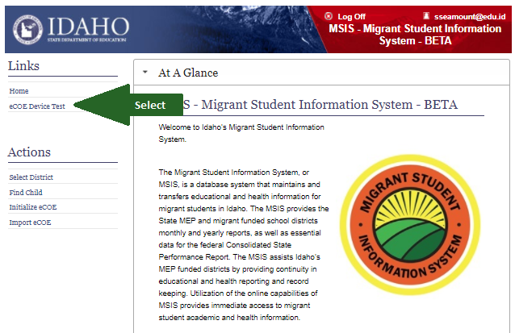
- Sign in the signature area. If the signature is not clear here, it will not be clear in the eCOE or on the printed copy provided to the family. If it is less than clear, consider a device with a higher resolution display.
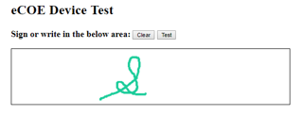
- Run the test to make sure the device is compatible. You should see a message below the signature box that says, “This device is compatible!”

Initialize the device
Before going into the field to create your first eCOE you must prepare the device in a location where internet is available.
- Log into MSIS.
- Click Initialize eCOE in the Actions menu in the navigation bar on the left.
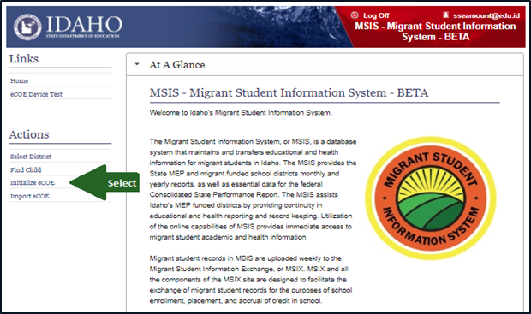
- If you have not previously initialized a device, enter a passphrase – see below guidelines for passphrase creation. Click the Submit button. (Note: If you have previously initialized a device, your saved passphrase will automatically be used to encrypt eCOE data on the device. When using multiple devices, it is best to use the same passphrase on all of them.)
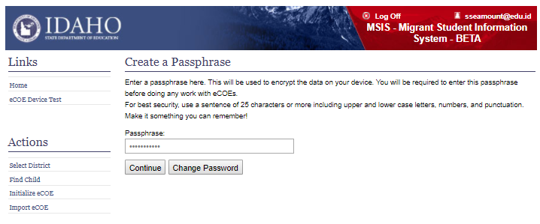
- Click the Continue button – this will take you to the eCOE page.
- Create a bookmark or a favorite for the eCOE page. THIS STEP IS CRITICAL!
- Log in to the eCOE page using the password you just created.
- Click on New eCOE. You are creating a test COE, so it will not be complete. All you need to do is select a district on the Family Data tab, and save it.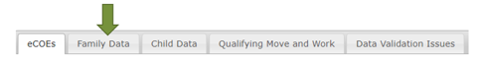
- Close the browser and power down the device.
- Turn the device on, log on, open the browser, and navigate to your eCOE bookmark or favorite. Make sure the eCOE you created is still there.
  - If it is, delete it. Your test was successful.
  - If it is not there, check your browser’s settings. Make sure they are not configured to automatically delete website data when the browser is closed.
Important: Using the browser bookmark or favorite is how you will access the eCOE page offline in the future. Without it, you will not be able to work offline.

Using a device that was initialized by someone else
- Log into MSIS.
- Click Initialize eCOE in the Actions menu on the navigation bar on the left.
- If you have not previously initialized a device, enter a passphrase – see below guidelines for passphrase creation. Click the Submit button.
- If your passphrase does not match the passphrase used to encrypt the device, the webpage will display a warning. Stop here and contact the Idaho MSIS Administrator at MsisAdministrators@sde.idaho.gov for help resolving this.
- Click the Continue button – this will take you to the eCOE page.
- Create a bookmark or a favorite for the eCOE page.
Important: Using the browser bookmark or favorite is how you will access the eCOE page offline in the future. Without it, you will not be able to work offline.

Guidelines for passphrase creation
- Your passphrase must contain at least 8 characters.
- Your passphrase cannot contain the “<” or the “>” character. Note that Initialize eCOE will not let you use these characters.
- Use a unique passphrase. DO NOT use your network password or the password to your email account or the password to your bank account. The passphrase will be encrypted and stored in the MSIS database so in an emergency eCOEs can be recovered from the device.
- For best security, use a sentence that will be easy for you to remember. Some examples are, “I love Paris in the summer.” or “My dog only has four legs.” As sentence is actually easier to remember than a weird password with a lot of non-alphabet characters, and is more secure as well. Include capital letters, spaces, and punctuation as you wish.
- If you forget your passphrase, you can always log into MSIS and go to the Initialize eCOE page and hover over the passphrase for a reminder.
- Important information:
  - The eCOE page uses local storage to store eCOE data. Local storage is browser specific. If you create eCOEs in Chrome you will not be able to access them in Safari and vice versa.
  - Clearing cache, cookies, website data, history, or temporary internet files should be done VERY carefully to avoid deleting any eCOEs that have not been imported into MSIS. The sooner you import eCOEs into MSIS, the lower the chances of this happening.
  - If someone suddenly leaves and their device contains eCOEs that have not been imported into MSIS, please contact the Idaho MSIS Administrator at MsisAdministrators@sde.idaho.gov, as we may be able to help recover them.

Creating an eCOE
This section includes step-by-step instructions on how to create an eCOE.

Beginning
- Turn the device on, open the browser, and navigate to your eCOE bookmark or favorite. (This does NOT require internet.)
- Enter your passphrase.
- You will see the Current Local COEs screen.
  - This is the screen you will use to create new COEs. To create a new one click on the New COE button.
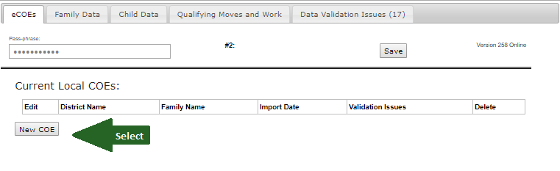
  - You will use this screen to look at the list of COEs currently on the device and to edit an existing COE. Select a COE from the list to edit it.
  - You will also delete COEs from this screen. File management is important, so do not allow COEs to accumulate. After they have been imported, they must be deleted from the local device. You can get the file back onto the device if you later need to make corrections.
Once you select the eCOE to edit or start a new eCOE you will see 5 tabs across the top of the page (Family Data, Child Data, Qualifying Moves and Work, Data Validation Issues). Note that a new eCOE will show 17 validation Issues. As you complete the various parts of the eCOE, they will disappear.
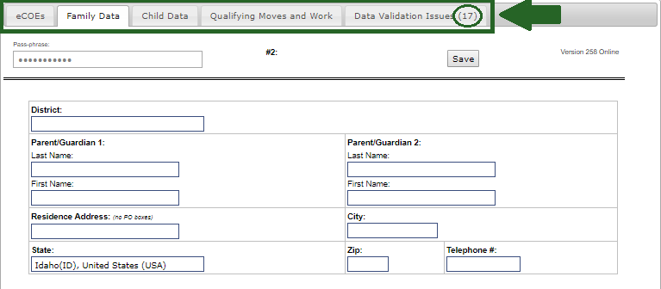
TAB: Family Data (If necessary, information can be corrected/entered later.)
- Click on the Family Data tab.
- Enter the school District where the student resides.
- Enter the Parent/Guardian 1 and Parent/Guardian 2 information if applicable.
- Enter the Residence Address where the family resides (no PO boxes).
- Enter the Telephone #. Include area code.
- Click SAVE.

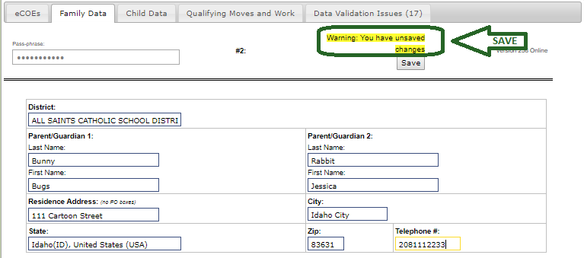

TAB: Child Data
(If necessary, information can be corrected/entered later.)
- Click on Add Child.
- Enter the information for a qualifying child.
- Click Save Child.
- Repeat these steps for each child in the family.
The screenshot below show the Child Data screen before saving.
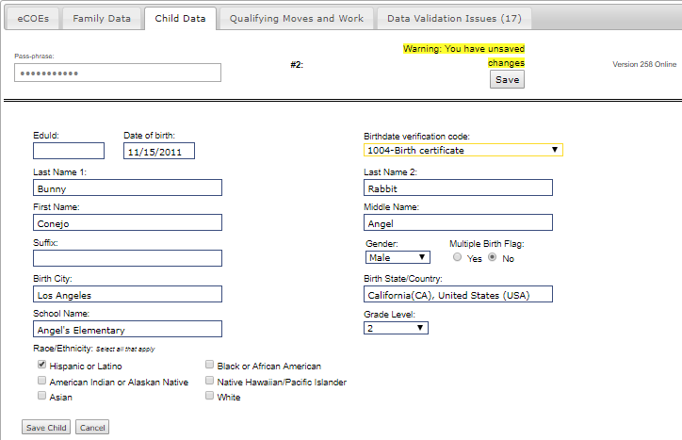

The screenshot below shows the Child Data screen after saving. Note that you can add more children here by clicking Add Child.
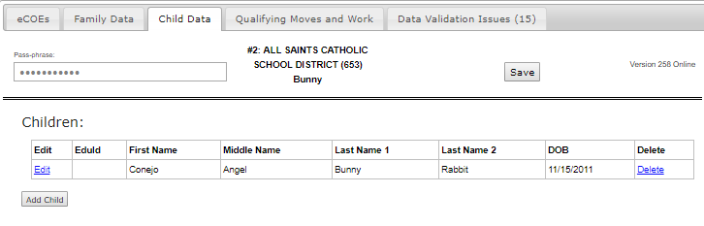

TAB: Qualifying Moves and Work
(CANNOT be changed after parents sign.)
- Click on Qualifying Moves and Work. You can open each section as you complete it and close them when you are done, or you can open them and leave them all open.
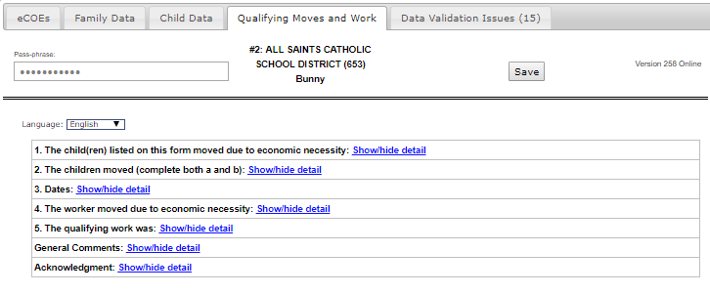

QMW Question #1
- Complete question #1: The child(ren) listed on this form moved due to economic necessity from a residence in <blank> to a residence <blank.>
- If the child(ren) come from and Idaho school, complete the From district.
- You must have a City and State for From and To.
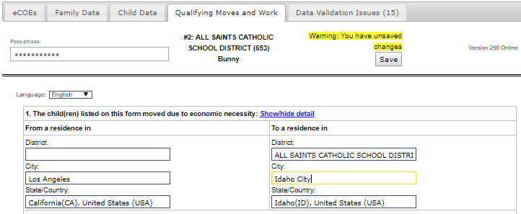

QMW Question #2
- Complete question #2: The child(ren) moved (complete both a and b).
- The standard response to question #2 part a is with the worker. This response only requires the worker name and relationship to child.
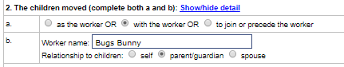

Note: Any response that requires a “Comment” will automatically open a comment box in that area. If you don’t provide the comment, it will create a notification issue and you will not be able to submit the COE until the comment is completed. In the example below, when “to join the worker” was selected, it opened other boxes (see below).
In this example, since to join or precede the worker, is selected the boxes for worker and child move dates and a comment are now showing and must be completed.
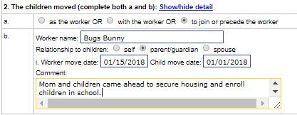

QMW Question #3
- Complete question #3: Dates.
- This question asks for the Qualifying Arrival Date.
- It also includes the children’s Residency Date, although this date will show on the Child Data section on the printed COE in the same way it does on the paper COE.

QMW Question #4
- Complete question #4: The worker moved due to economic necessity.
- This question asks for dates and locations of the worker’s move and his or her status as an agricultural worker.
- Use a1: engaged in new qualifying work within 60 days of the move whenever possible, even if the qualifying move is in the past (within 36 months).
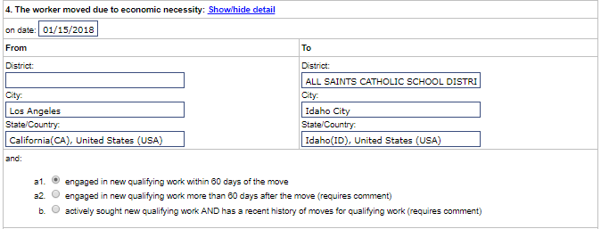

QMW Question #5
- Complete Question #5: the qualifying work was <blank.>
- This question asks if the work is seasonal or temporary and agricultural or fishing.
- In addition, you must enter the activity using the “verb+ing noun” format. In the example below, the activity is “pruning apple trees.”
- If personal subsistence is selected, seek assistance from your region ID&R coordinator to correctly complete the comment.
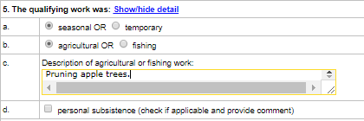

General Comments
As on the paper COE, general comments are not required and should only be used if needed.
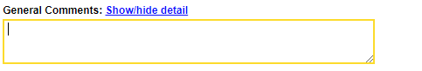

Acknowledgment
- You must complete all tabs in Qualifying Moves and Work BEFORE the interviewee signs the document in Acknowledgment.
- If the interviewee is more comfortable reading in Spanish, change the language to Spanish when you open the Acknowledgment area.
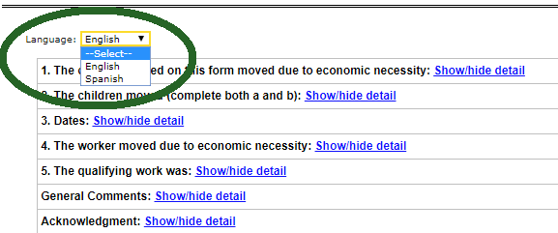
- Have interviewee read the acknowledgment and review your work.
- Always offer to explain the acknowledgement to the interviewee.
- Ask the interviewee to select and sign the acknowledgment.
- You or the interviewee can type in his or her relationship to the child for the acknowledgment.
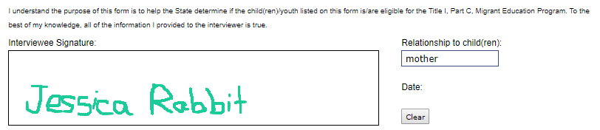
- If the interviewee is the child(ren)’s parent, ask the parent to read the FERPA release.
- Offer to explain the FERPA rights and the proposed release.
- Ask the parent to select “yes” or “no.”
- Ask the parent to select his or her relationship to the child from the dropdown menu. Choices are parent, guardian, or self. “Self” may be used by emancipated or unaccompanied youth or an adult of 18 or more years of age.
- When the parent is satisfied with the signature(s), he or she must click on Accept to finalize the signature(s).
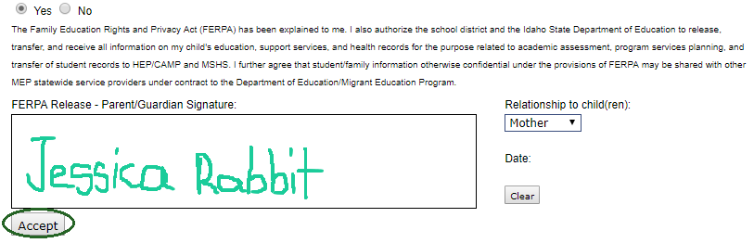
*CAUTION* The information in the “Qualifying Move and Work” section CANNOT be changed once the parents have signed and accepted. If changes must be made to any question in this section, the signature must be cleared and the parents re-sign after the changes are made.

Data Validation Issues
- Check the Data Validation Issues tab before concluding the interview.
- Missing Family Data will include the phrase some required fields are missing values.
- Missing Child information will specify which field for which child is incomplete. If no children are entered, the phrase COE must have at least one child will appear.
- If the Qualifying Move and Work section has any problems, complete those before the parent signs. These are marked as QMW-# with the number of the question that has the validation issue.
- When there are no validation issues remaining, the eCOE is complete and ready for importing.

eCOE Workflow
The workflow of the eCOE will make it much faster to qualify a family than it was with paper COEs. Ideally, you will complete and submit the eCOE the same day you interview the parents. The regional will receive an email that a COE is waiting and will submit or reject the COE. Then the Idaho MEP program specialist will approve or reject it. At that point you will receive an automatic email stating that the COE is approved and in the system or has been rejected and needs corrections. This should be accomplished within one week of submission of an eCOE.

Importing and Submitting a new eCOE – Liaisons:
In order to import, finalize and submit a new COE, you must have access to internet and your school information system. This should be done on a secure connection. Typically, Wi-Fi access in public places (e.g. coffee shop, local library, restaurant) will be public or open and not secure. Wi-Fi access in a school is generally secure. Check with your district IT department to be sure that you are using a secure connection in your school.

Getting Ready to Import
- Click on your bookmark or favorite for the eCOE.
- Click on Initialize eCOE.
- Log in using your eCOE passphrase.
- On the eCOEs tab, select an existing eCOE.
- Verify information with your school information system (e.g. name spelling, date of birth, etc.)
- Make sure there are no issues listed on the Data Validation Issues tab. If none are listed, you are ready to begin the import.
- Close the eCOE.

Importing
- Log into MSIS.
You MUST be logged into MSIS to import eCOEs from your device.
- Click on Import eCOE link in your Actions menu on the navigation bar on the left.
- Enter your eCOE passphrase.
- Click the Import button in the Action column on the right side of the COE you wish to import. Note: this button will not appear if the eCOE has Validation Issues.
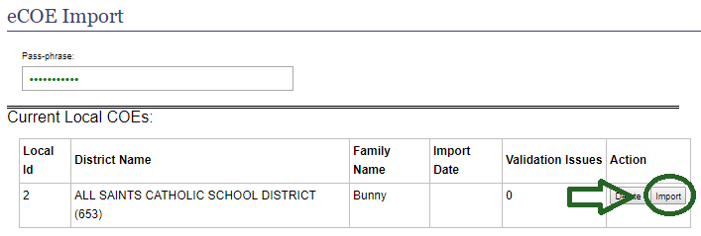
- If import was successful, you will see the message, “Congratulations! You’ve imported local COE ID number < > from your device.” Along with a summary of information about the COE. Check this information to confirm its accuracy.
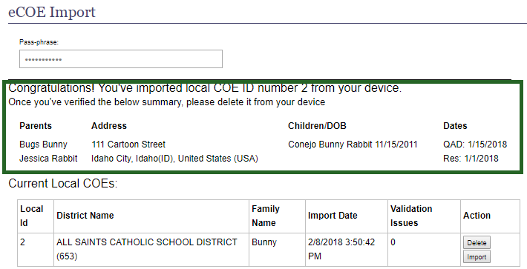
- Delete the imported eCOE from the device by clicking the Delete button in the Action column on the right.
The dire warning is to keep you for accidentally deleting a COE that has not been imported.
- The eCOE will now appear in the Pending eCOEs list of the district the eCOE was created for.
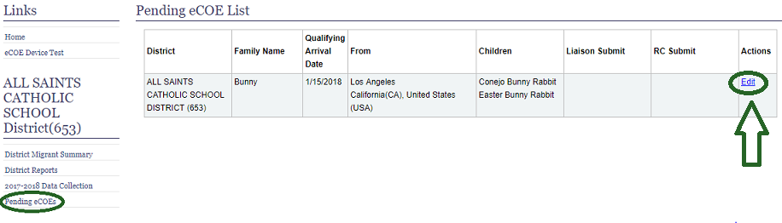
- Click the Edit link for the selected eCOE in the Pending eCOEs list.
- Verify all information on the eCOE.
- Save any changes. Note: changes cannot be made to the Qualifying Move and Work tab.
- When satisfied, click the Submit button. This will generate an email notification to the Regional Coordinator associated with that district. (A sample email is below.)
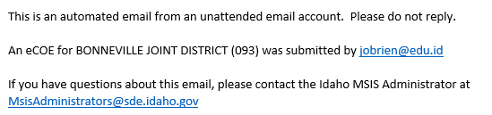

Reviewing and Submitting – Regional Coordinators:
- Select the appropriate district from the Select District link in your Actions menu.
- Click Pending eCOEs from the navigation bar on the left.
- Click the Edit link for the eCOE you need to approve.
- Review each tab (Family Data, Child Data, Qualifying Moves and Work) for accuracy and completeness (see screenshot below). Be sure to check every part of the Qualifying Moves and Work section, paying particular attention to comments.
- For each child on the Child Data tab:
- Click the Find Child button.
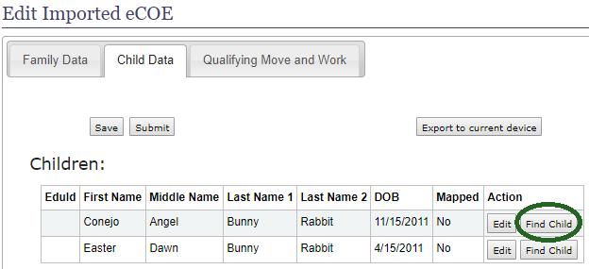
- If no suitable candidates are found, click the Generate New Eduid button.
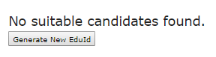
- From the list of candidates provided, click the Use This Child button for the correct child.
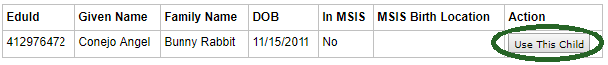
- Save often!
- If there are issues that need to be resolved by the liaison:
  - Click the Reject button.
  - Enter a Rejection Reason and click Save.
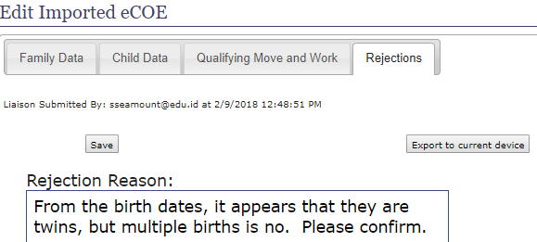
  - The eCOE will be un-submitted and a notification email will be sent to the liaison that originally submitted it. (A sample email is below.)
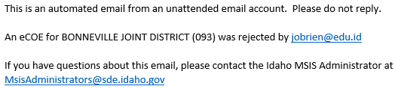
- When you are satisfied that the eCOE can be approved:
- Click the Submit button. You will see the date and time you submitted it.
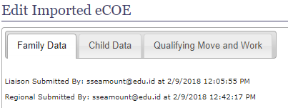
- There will not be a Submit button if there are any validation issues. (If validation issues should be resolved, but you don’t see a submit button, you may need to Save.)
- This will generate an email to the SDE Admin and remove the eCOE from the district’s Pending eCOEs list. (A sample email is below.)
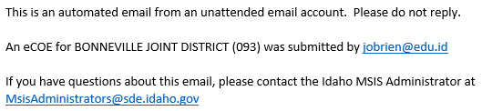

Approving – SDE Program Specialist:
- From the Pending eCOEs list in your Admin Actions menu, click the Edit link for the eCOE you wish to review.
- Review each tab (Family Data, Child Data, Qualifying Moves and Work) for accuracy and completeness. Be sure to check every part of the Qualifying Moves and Work section, paying particular attention to comments.
- If there are issues that need to be resolved:
- Click the Reject button
- Enter a Rejection Reason, and click Save.
- The eCOE will be un-submitted and a notification email will be sent to the Liaison that originally submitted it and the Regional Coordinator that approved and submitted it.
- When you are satisfied that the eCOE can be approved:
- Click the Approve button.
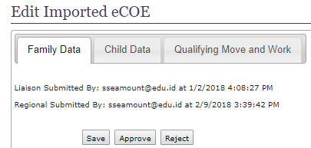
- You will see the Dates that the COE was submitted by the liaison and regional coordinator, as well as a COE number and opportunity to view the certificate.
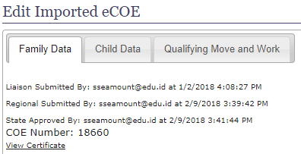
- Approving the COE will generate an email notification to the Liaison and the Regional Coordinator that submitted it. The email will include the new COE number along with important instructions to forward a copy of the eCOE to parents and to notify food service that the children on the COE should receive free lunch.
- Once approved, the eCOE will no longer appear in any Pending eCOEs list. The eCOE will become a Movement and will appear in the District Migrant Summary of the district in which the eCOE was created.

After approval:
- The liaison will receive an email, informing him or her that the eCOE has been approved and is active in MSIS. The email will include the COE number and instructions included here (i.e. copy of COE to parents, notify food service).
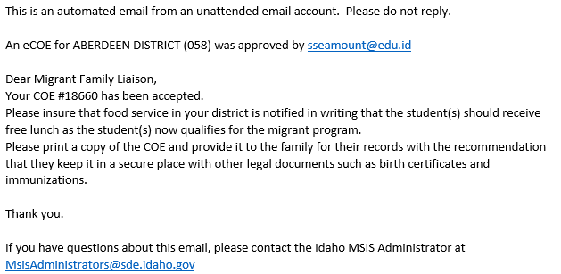
- Click on District Migrant Summary in the navigation bar on the left.
- Find the child. Click on the Child’s name.
- In the tabs of the Child Detail, click on Movement History.
- Click on View Movement Detail.
- Click on View Certificate on the far right of the screen. (View eCOE will show you the eCOE tabs.)
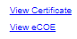
- Open the PDF Certificate generated to the bottom left of the screen. (Only English is currently available. Spanish will be added after the pilot.)
- Print a copy of the eCOE and return it to the parents with the information that the COE is an important legal document that should be kept with other important documents, such as birth certificates and immunization records.
- A second printed copy of the eCOE must be placed in the cumulative record if the child is enrolled in school.
- Food services must be notified that the children are in the migrant program and are entitled to free lunch.

