  - Title I-A
  - Annual Performance Report

Instructions
Title I-A Coordinators:
As a part of the Title I-A program, the 2022-2023 Annual Performance Report needs to be completed by LEAs receiving Title I-A funds. Please put this on your “to do” list as soon as you can. Please do not wait until the deadline to view and complete this report, as if you have errors, these MUST be corrected before you can submit your application.

Complete and submit the report NO LATER THAN SEPTEMBER 29, 2023. Thank you for all your work with Federal Programs.

The 2022-2023 Title I-A Annual Performance Report is now available at the Idaho State Department of Education website located at: https://apps.sde.idaho.gov/AnnualPerformanceReport
Follow these directions to correctly complete the LEA APR:
- Click on the Annual Performance Report application link.

- Log On to the Annual Performance Report. If you are unable to Log On, please contact your district/LEA ISEE coordinator.

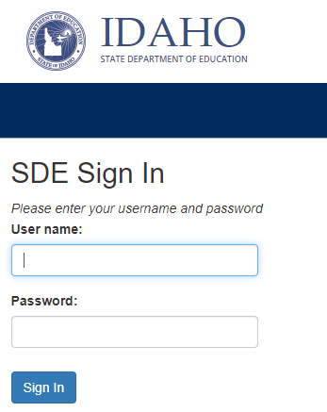

- Make sure you are on the 2022-2023 homepage for your district/LEA.

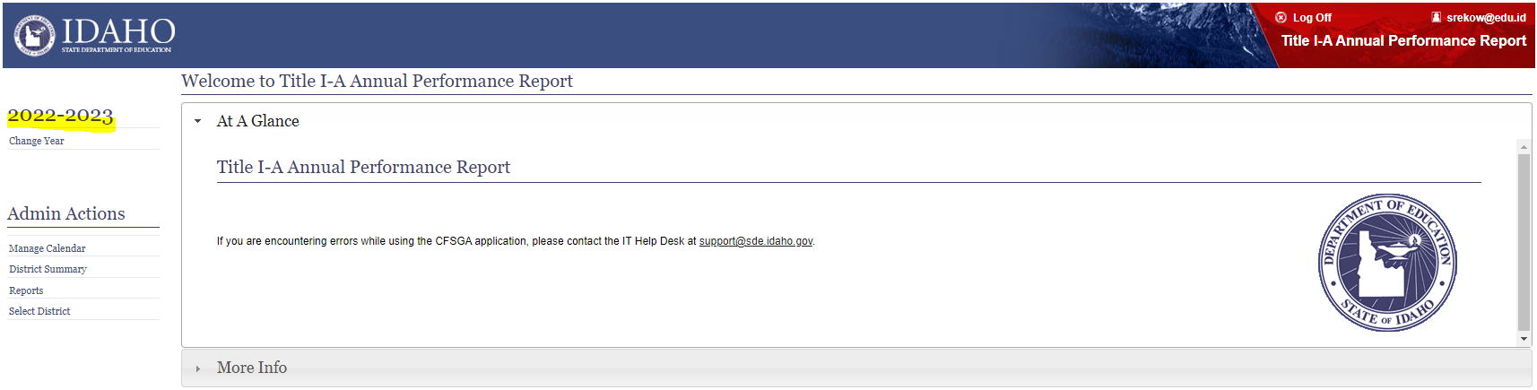

- Click on the Title I-A Annual Performance Report under the district name on the left.

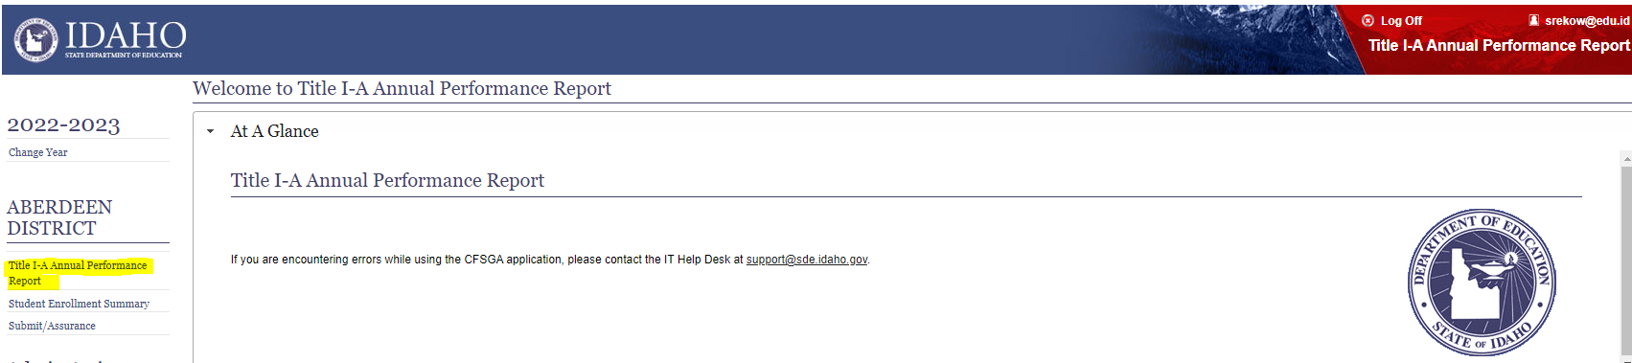

- GENERAL INFORMATION tab- Begin typing your name in the text box for Contact Person. Contact Person choices will appear with email address. If your name and current email address is listed, click on your contact information. Then click on Save. If you are not listed as the Contact Person, communicate with your IT staff to find out who is assigned as the Contact Person for your LEA and enter that information. If no one is assigned to the Title I-A Annual Performance Report for your LEA, you will need to have a Contact Person added by your LEA IT staff.
S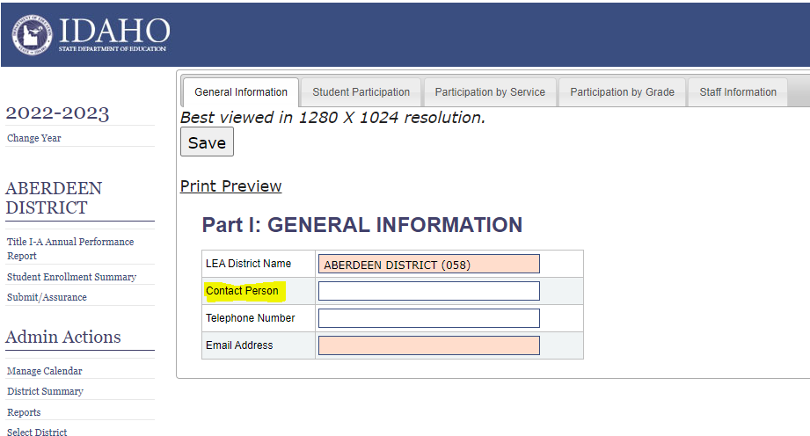

- STUDENT PARTICIPATION tab- This information is pre-populated through ISEE. (Note: Salmon colored cells are pre-populated.) Please review the data and make sure it matches your records. If changes are needed, this can be done through an ISEE upload.

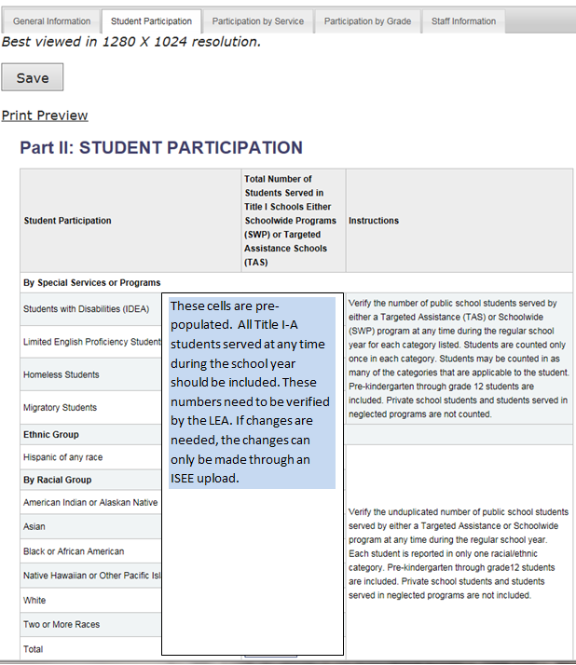

- Participation by Service tab- IF you have students in a Targeted Assistance program, please enter the number of students receiving each of the listed instructional and support services received through a Targeted Assistance program funded by Title I-A. Students may be reported as receiving more than one service. If you only have Schoolwide programs, these numbers will remain zero (0). Don’t forget to click on Save after you enter your data.
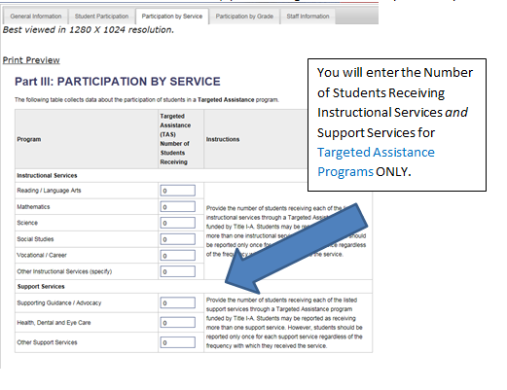

- PARTICIPATION BY GRADE tab- The Public Targeted Assistance School (TAS) and Public Schoolwide Program (SWP) students are prepopulated in the first two columns. IF you have any private school students and/or neglected programs students participating in Title I-A programs, please insert those numbers in the 3rd and 4th columns respectively. Click on Save after making any changes.
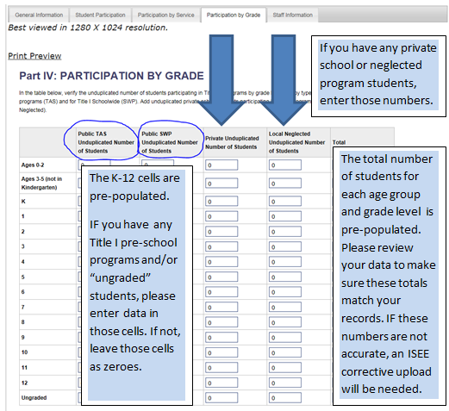
- If it is determined that there is a discrepancy between the data in the Annual Performance Report and LEA data, then do the following:
  - Click on the Student Enrollment Summary link on the left hand navigational toolbar to view EdUID level data. This is a summary of all students enrolled in the district at any time during the year from your ISEE uploads. The students that are included in the Title I-A Annual Performance Report are highlighted in blue.
  - Make necessary changes in the student management system.
  - Submit a Corrective ISEE upload. Contact your regional ISEE Technical Coordinator for help, if needed.
  - Regions 1, 2 & 3: Amy Sigler at 208.332.6981 or asigler@sde.idaho.gov
  - Regions 4, 5 & 6: Roger Evans at 208.332.6982 or revans@sde.idaho.gov
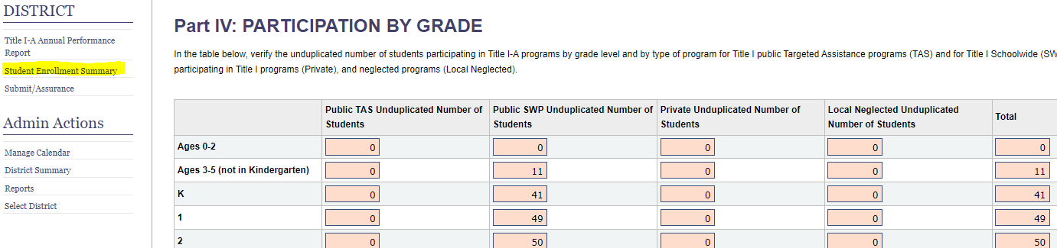

- STAFF INFORMATION tab- Please enter your Staff Information for Targeted Assistance Programs and Paraprofessional Information for Schoolwide Programs for the 2019-20 school year in the corresponding cells. The information is to be entered as full time equivalent (FTE). The numbers you enter here should reflect the numbers in your 2019-20 CFSGA. Remember to Click on Save after entering your data.

NOTE: Title I Targeted Assistance (TAS) Staff FTE information includes ONLY staff funded by Title I funds.
Title I Schoolwide (SWP) FTE information includes ALL paraprofessionals serving in Schoolwide Programs.
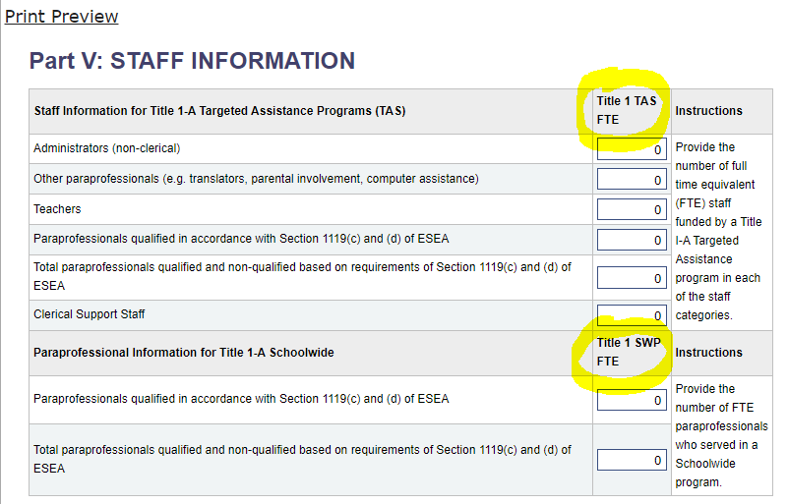

- Submit/Assurance- When you are sure all of your information is complete, click on Submit/Assurance, which is highlighted on the left. After you click on the link, you will either see errors which need to be corrected before your application can be submitted, or you will see an Assurance which you will complete. If you have any error messages, address the error(s), click on Save under each tab again, then submit your report.

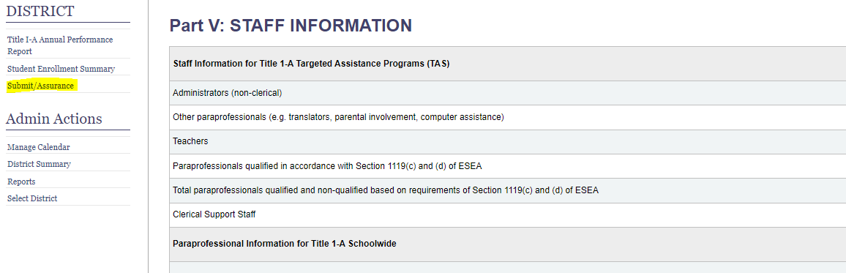

If you are still unable to submit your report, please contact srekow@sde.idaho.gov for technical assistance.
For Questions Contact
Stacie Rekow, Title I-A Coordinator
Federal Programs
Idaho State Department of Education
650 W State Street, Boise, ID 83702
208.332.6891 | srekow@sde.idaho.gov

