Sample Parent Employment Survey Procedures – Migrant District

Dear Secretary or registrar,

The most important step in identifying migrant students is the Parent Employment Survey filled out by parents or guardians at enrollment. Please use the following procedures to make sure that we are able to identify these students effectively and in a timely manner. Call the migrant family liaison if you have any questions. Thank you.

- Include the Parent Employment Survey in the registration packet for all new students.

- Pre-screen and complete the surveys process as follows:
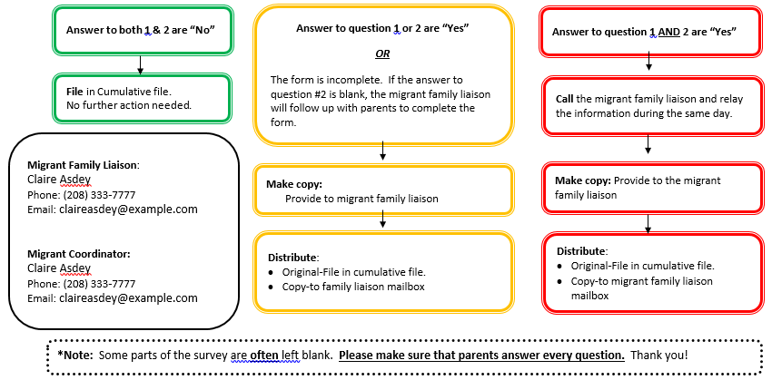

Parent Employment Survey Procedures – Migrant District

Dear Secretary or registrar,

The most important step in identifying migrant students is the Parent Employment Survey filled out by parents or guardians at enrollment. Please use the following procedures to make sure that we are able to identify these students effectively and in a timely manner. Call the migrant family liaison if you have any questions. Thank you.

- Include the Parent Employment Survey in the registration packet for all new students.

- Pre-screen and complete the surveys process as follows:
Distribute:
- Original-File in cumulative file.
- Copy-to migrant family liaison mailbox
Make copy: Provide to the migrant family liaison
Call the migrant family liaison and relay the information during the same day.
Distribute:
- Original-File in cumulative file.
- Copy-to family liaison mailbox
Make copy:
Provide to migrant family liaison
*Note: Some parts of the survey are often left blank. Please make sure that parents answer every question. Thank you!
Migrant Family Liaison:
(Name)
Phone:
Email:

Migrant Coordinator:
(Name)
Phone:
Email:
Answer to both 1 & 2 are “No”
File in Cumulative file.
No further action needed.
Answer to question 1 AND 2 are “Yes”
Answer to question 1 or 2 are “Yes”

OR

The form is incomplete. If the answer to question #2 is blank, the migrant family liaison will follow up with parents to complete the form.

