Title I-A Comparability Reporting

New Process

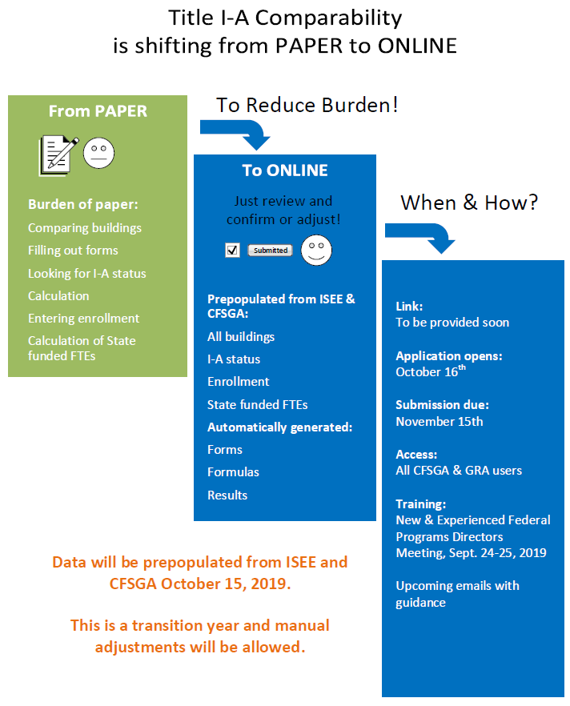

Description of the Chart
In order to reduce administrative burden, Title I-A Comparability reporting is shifting from paper to online submission. Paper submission used to involve manually comparing buildings to each other, filling out the forms, looking up for a Title I-A status for each building, entering enrollment and State-funded FTEs and calculating the results by using ratios and formulas.
Online submission will reduce administrative burden because the new Application will be connected to the Idaho System for Educational Excellence (ISEE) and the Consolidated Federal and State Grant application (CFSGA). The new Application will use the ISEE to prepopulate a snapshot of enrollment and State-funded FTEs reported by October 15 of this year. The new Application will use the CFSGA to prepopulate the Title I-A status for each school. This application is designed to recognize which forms (approach) benefits each LEA the most. All applicable forms will be prepopulated with corresponding formulas. An LEA will review the report and either confirm or adjust data. Manual adjustments will be allowed.
Link to the application will be provided soon. The Application opens on October 16th, 2019. Submission due date is November 15th, 2019. All current CFSGA and Grant Reimbursement Application (GRA) users will automatically have access to the new Application. Training sessions will be offered during the New and Experienced Federal Programs Directors Meeting, September 24-25, 2019. Additional emails with guidance will be sent to all LEAs.

